**SQL BASICS**

Structured Query Language(SQL) is the database language by the use of which we can perform certain operations on the existing database and also we can use this language to create a database. SQL uses certain commands like Create, Drop, Insert, etc. to carry out the required tasks.

These SQL commands are mainly categorized into three categories as:

1. DDL – Data Definition Language
2. DML – Data Manipulation Language
3. DCL – Data Control Language

**DDL**

DDL or Data Definition Language actually consists of the SQL commands that can be used to define the database schema. It simply deals with descriptions of the database schema and is used to create and modify the structure of database objects in the database. DDL is a set of SQL commands used to create, modify, and delete database structures but not data.

List of DDL commands:

* **CREATE**: This command is used to create the database or its objects (like table, index, function, views, store procedure, and triggers).
* **DROP**: This command is used to delete objects from the database.
* **ALTER:**This is used to alter the structure of the database.
* **TRUNCATE:**This is used to remove all records from a table, including all spaces allocated for the records are removed.
* **COMMENT**: This is used to add comments to the data dictionary.
* **RENAME:**This is used to rename an object existing in the database.

**DML**

The SQL commands that deals with the manipulation of data present in the database belong to DML or Data Manipulation Language and this includes most of the SQL statements. It is the component of the SQL statement that controls access to data and to the database. Basically, DCL statements are grouped with DML statements.

List of DML commands:

* **INSERT**: It is used to insert data into a table.
* **UPDATE:** It is used to update existing data within a table.
* **DELETE** : It is used to delete records from a database table.
* **CREATE TABLE CONTACT**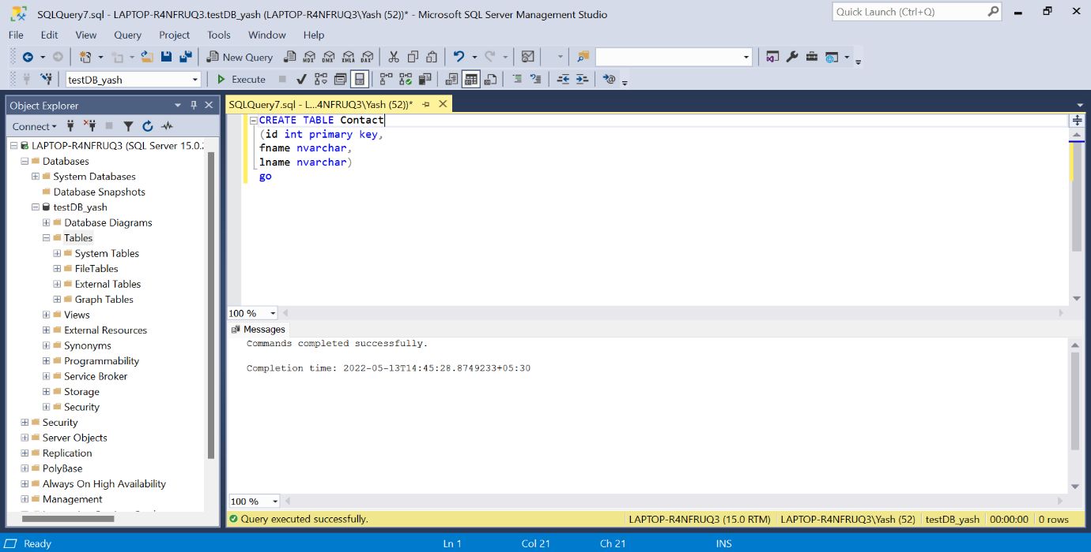
* **ALTER TABLE CONTACT AND SELECT * FROM CONTACT**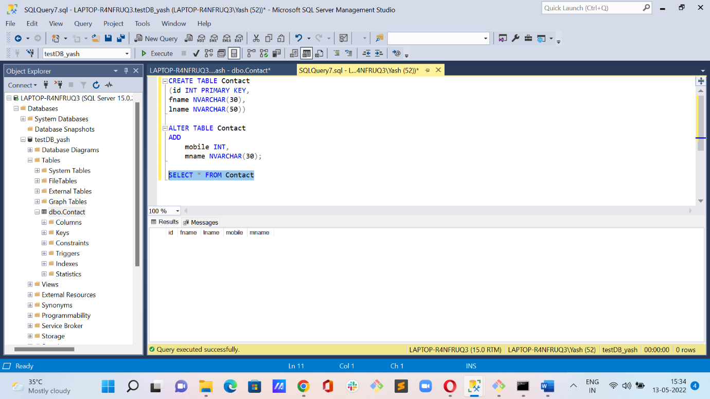
* **UPDATE TABLE CONTACT AND SELECT * FROM CONTACT**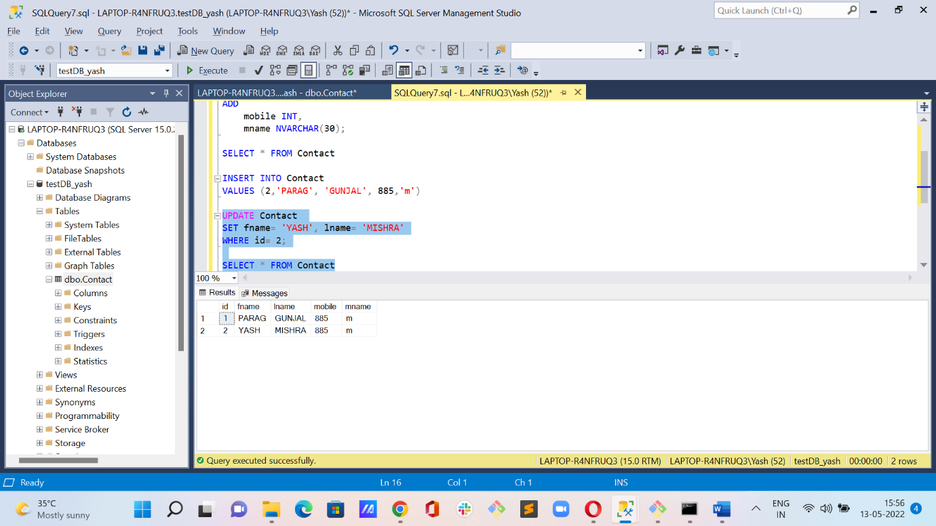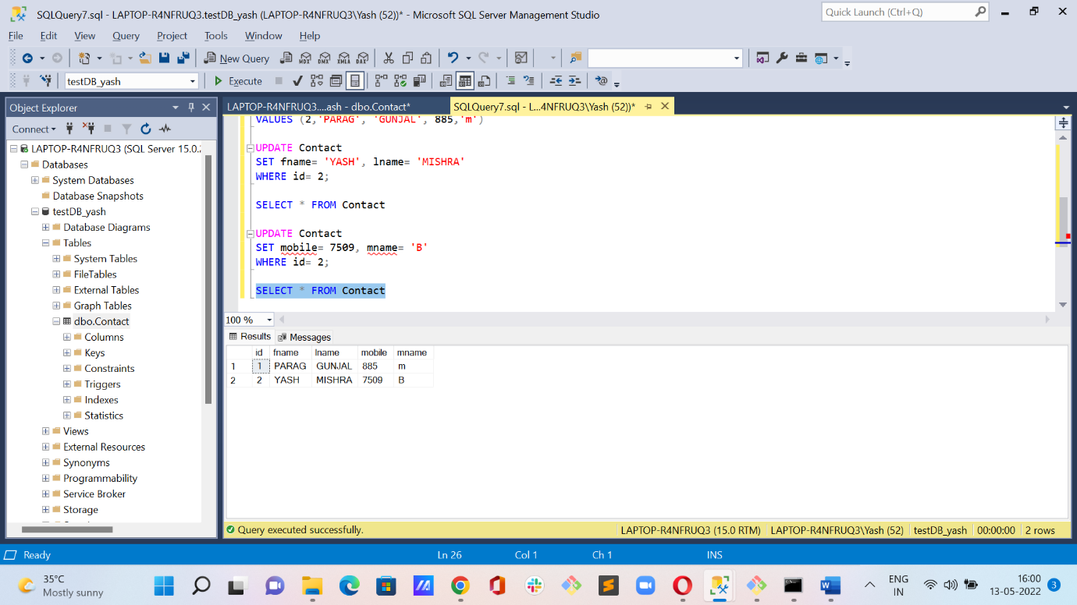
* **DELETE TABLE CONTACT AND SELECT * FROM CONTACT**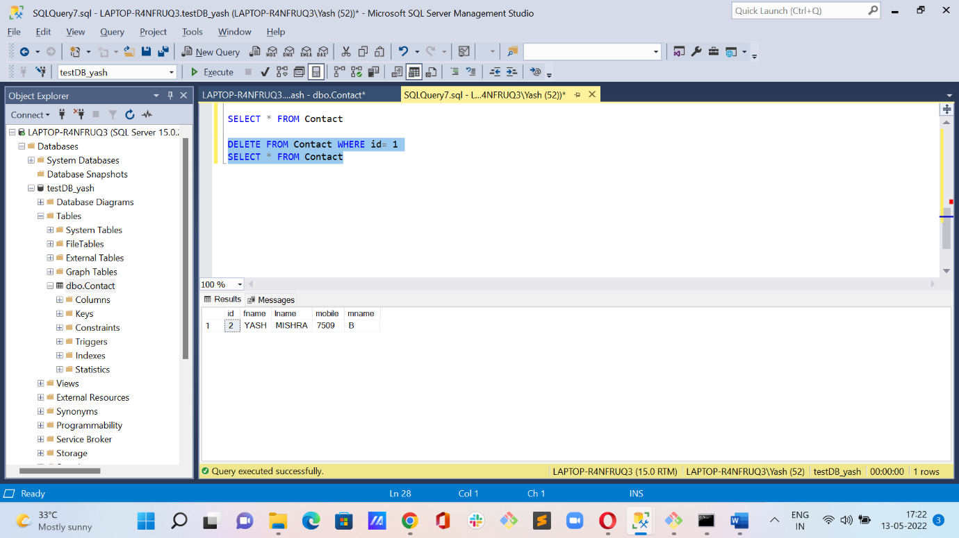
* **INSERT NEW RECORD AND SELECT * FROM CONTACT**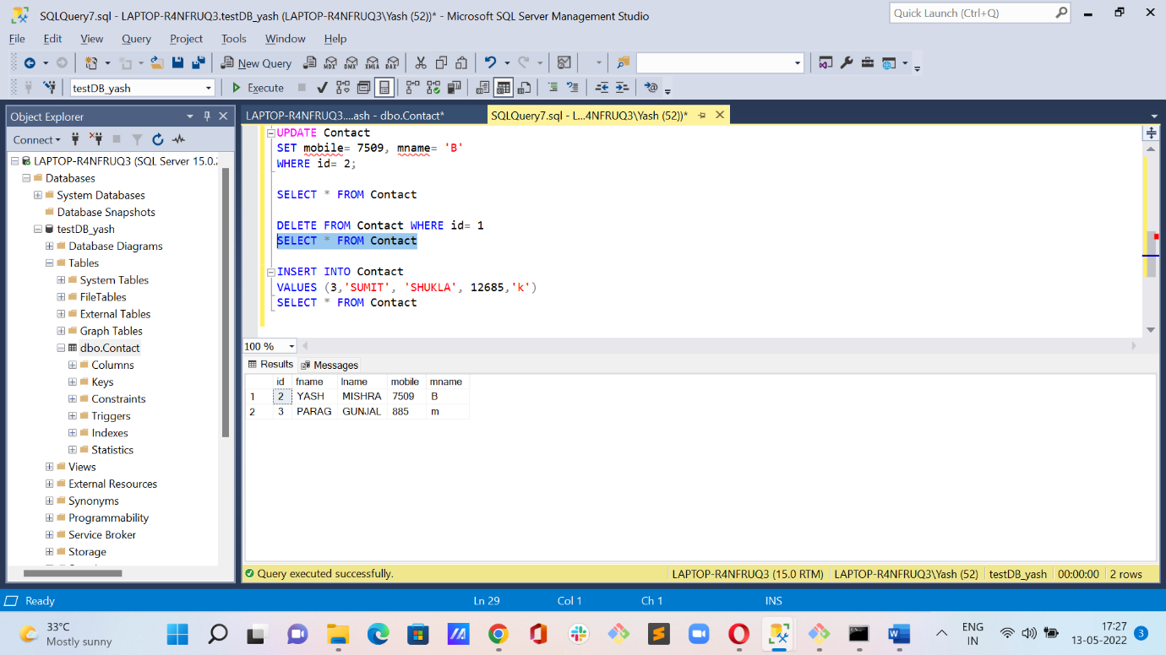
* **INSERTING NEW RECORD AT SAME ID=3 AND SELECT * FROM CONTACT**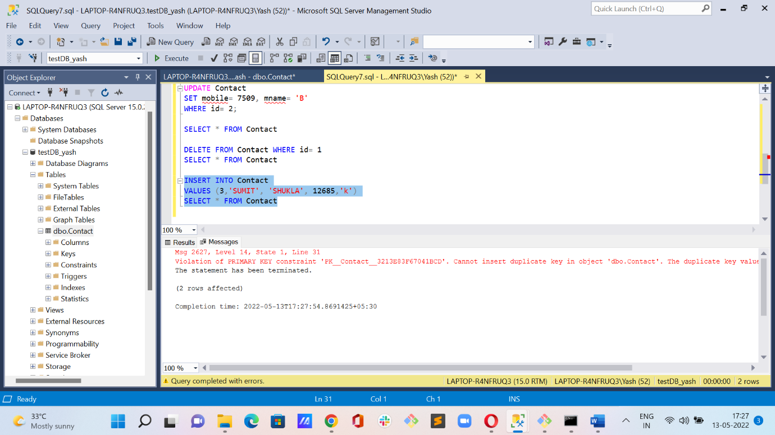
* **INSERTING NEW RECORD AT DELETED ID=1 AND SELECT * FROM CONTACT(ERROR: RECORD ADDED(PRIMARY KEY PRINCIPLE VIOLATED)**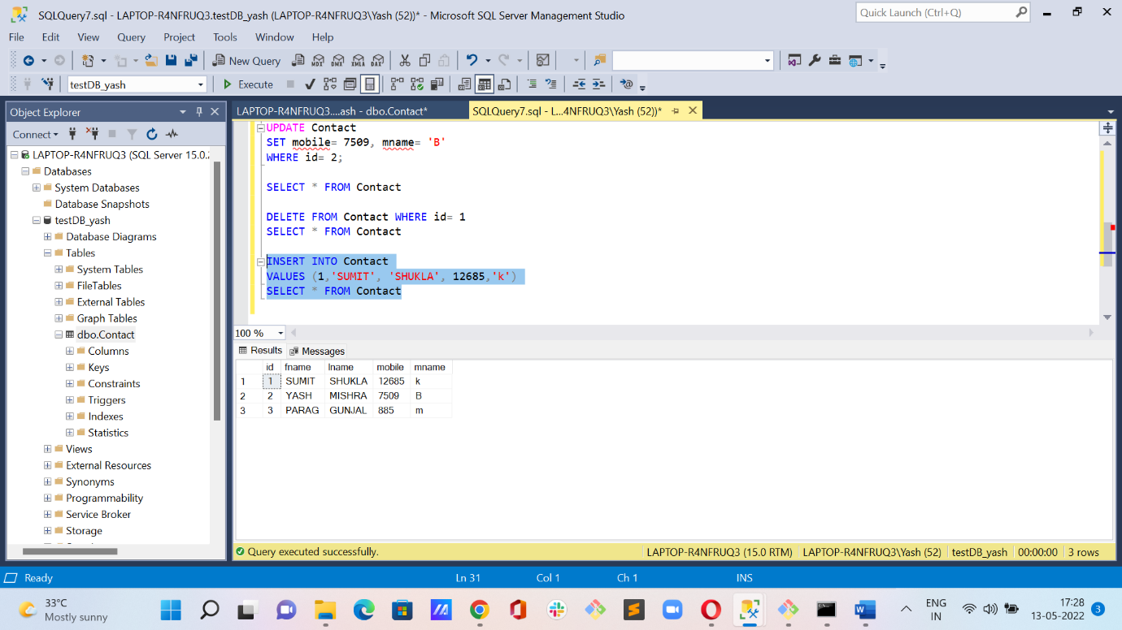
* DOUBT- How did the record got added at id(primary key)= 1 which was deleted previously ? Need to understand what’s wrong here because, primary key doesn’t let use the same id even after deletion of record at that particular id.
* **DROP TABLE CONTACT AND SELECT * FROM CONTACT**